**Create_user**

<http://doannt106.hunn.io.vn/Create_User>

Post

Body:

{

    "Username": "duyt1",

    "Email":"duyt1@gmail.com",

    "Password":"12345",

    "Name":"duyt1"

}

Trả về  
{

    "message": "User created successfully!"

}

**Login**

(Post):

<http://doannt106.hunn.io.vn/login>

**Body:**

{

    "Identifier": "duyt1",

    "Password":"12345"

}

Trả về:

{

    "message": "Login successful!",

    "username": "duyt1",

    "user_id": "6765481c328f7fb2c3cee4c6"

}

**Createproject**

[**http://doannt106.hunn.io.vn/createproject**](http://doannt106.hunn.io.vn/createproject)

**Post**

**Body:**

{

    "ProjectName": "project",

    "Description": "khong biet",

    "StartDate": "2012/12/12/",

    "EndDate": "2013/12/25",

    "Status": "Ongoing",

    "CreatedBy": "6765481c328f7fb2c3cee4c6",

    "Members": ["taolata","thien"]

}

**Trả về**

{

    "message": "Project created successfully!",

    "project_id": "67654aad328f7fb2c3cee4c7"

}

**Projectmember (add member)**

[**http://doannt106.hunn.io.vn/project_members**](http://doannt106.hunn.io.vn/project_members)

**Post**

**Body**

{

    "AdminID": "6765481c328f7fb2c3cee4c6",

    "ProjectID": "67654aad328f7fb2c3cee4c7",

    "Identifiers": ["Hunn","Hunntest"],

    "Role": "member"

}

**Trả về**{

    "message": "Members added successfully!",

    "added_members": [

        "Hunn"

    ]

}

**Project(project bao gồm id và project nào )**

**Get**

[**http://doannt106.hunn.io.vn/project?ProjectID=67654aad328f7fb2c3cee4c7&UserID=6765481c328f7fb2c3cee4c6**](http://doannt106.hunn.io.vn/project?ProjectID=67654aad328f7fb2c3cee4c7&UserID=6765481c328f7fb2c3cee4c6)

**(thay sau ProjectID là của người muốn tìm và userid của người đó )**

    "UserID": "6765481c328f7fb2c3cee4c6",

    "ProjectID": "67654aad328f7fb2c3cee4c7",

**Trả về**  
{

    "ProjectName": "project",

    "Description": "khong biet",

    "StartDate": "2012/12/12/",

    "EndDate": "2013/12/25",

    "Status": "Ongoing",

    "CreatedBy": "duyt1",

    "CreateDate": "2024-12-20T10:45:01.515Z",

    "Tasks": [],

    "Members": [

        {

            "MemberID": "6762763111d29583953e4010",

            "FullName": "thien",

            "Username": "thien",

            "Role": "Member"

        },

        {

            "MemberID": "676305926acb7235b732f2ee",

            "FullName": "taolatao",

            "Username": "taolata",

            "Role": "Member"

        },

        {

            "MemberID": "6765481c328f7fb2c3cee4c6",

            "FullName": "duyt1",

            "Username": "duyt1",

            "Role": "Owner"

        },

        {

            "MemberID": "6762a2f41bbd0b178f698d9e",

            "FullName": "Trần Thanh Hùng",

            "Username": "Hunn",

            "Role": "member"

        }

    ]

}

**Lưu ý** trong hình phần body ko cần do t lười xóa

**user_projects**

[**http://doannt106.hunn.io.vn/user_projects?UserID=6765481c328f7fb2c3cee4c6**](http://doannt106.hunn.io.vn/user_projects?UserID=6765481c328f7fb2c3cee4c6)

**(thay userid của người khác)**

**Trả về**

{

    "TotalProject": 1,

    "projects": [

        {

            "ProjectID": "67654aad328f7fb2c3cee4c7",

            "ProjectName": "project",

            "Description": "khong biet",

            "Status": "Ongoing",

            "StartDate": "2012/12/12/",

            "EndDate": "2013/12/25",

            "CreatedBy": "duyt1",

            "CreateDate": "2024-12-20T10:45:01.515Z",

            "UserRole": "Owner/Creator"

        }

    ]

}

**Lưu ý** trong hình phần body ko cần do t lười xóa

**Update_role_member**

[**http://doannt106.hunn.io.vn/update_member_role**](http://doannt106.hunn.io.vn/update_member_role)

**PUT**

**Body:**

{

   "AdminID":"6765481c328f7fb2c3cee4c6",

   "ProjectID":"67654aad328f7fb2c3cee4c7",

   "Identifier":"Hunn",

   "Role":"Owner"

}

**Trả về**{

    "message": "Member role updated successfully!"

}

**update_project_status**

[**http://doannt106.hunn.io.vn/update_project_status**](http://doannt106.hunn.io.vn/update_project_status)

**Body**

{

   "AdminID":"6765481c328f7fb2c3cee4c6",

   "ProjectID":"67654aad328f7fb2c3cee4c7",

   "Status":"Completed"

}

**Trả về**

{

    "message": "Project status updated successfully!"

}

**Deleteproject**

[**http://doannt106.hunn.io.vn/deleteproject**](http://doannt106.hunn.io.vn/deleteproject)

**Delete**

**Body**

{

   "AdminID":"6762763111d29583953e4010",

   "ProjectID":"676276c411d29583953e4011"

}

**Trả về**

{

    "message": "Project deleted successfully!"

}

**create_task**

[**http://doannt106.hunn.io.vn/create_task**](http://doannt106.hunn.io.vn/create_task)

**Post**

**Body**

{

    "ProjectID":"67654aad328f7fb2c3cee4c7",

    "Title":"lam viec gap",

    "Description":"nhanh len",

    "AssignedTo":["taolata","thien"],

    "DueDate":"1/1/2025",

    "AdminID":"6765481c328f7fb2c3cee4c6",

    "Status":"Ongoing"

}

**Trả về**

{

    "message": "Task created successfully!",

    "TaskID": "67655363328f7fb2c3cee4c8"

}

**assign_task**

[**http://doannt106.hunn.io.vn/assign_task**](http://doannt106.hunn.io.vn/assign_task)

**Put**

**Body**

{

    "TaskID":"67655363328f7fb2c3cee4c8",

    "ProjectID":"67654aad328f7fb2c3cee4c7",

    "AdminID":"6765481c328f7fb2c3cee4c6",

    "AssignedTo":["Hunn"]

}

**Trả về**

{

    "message": "Task assigned successfully!"

}

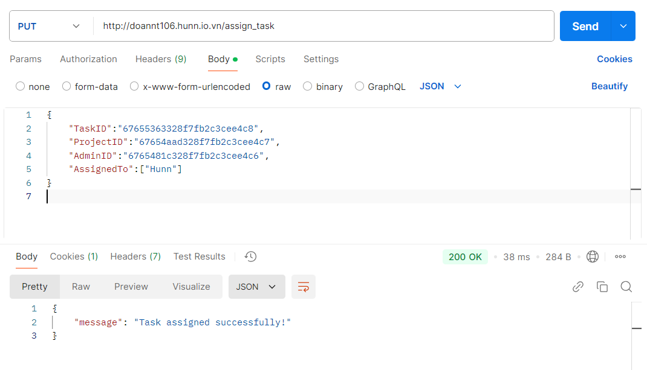

**update_task_progress**

**http://doannt106.hunn.io.vn/update_task_progress**

**PUT**

**Body**

{

    "TaskID":"67655363328f7fb2c3cee4c8",

    "UserID":"676305926acb7235b732f2ee",

    "Progress":"50%",

    "Status":"Completed"

}

Trả về

{

    "message": "Task progress updated successfully!"

}

**List task**

[**http://doannt106.hunn.io.vn/list_tasks?ProjectID=67654aad328f7fb2c3cee4c7&UserID=676305926acb7235b732f2ee**](http://doannt106.hunn.io.vn/list_tasks?ProjectID=67654aad328f7fb2c3cee4c7&UserID=676305926acb7235b732f2ee)

**(thay projectid của mình muốn xem và userid của mình ko phải của admin)**

**GET**

**Trả về**

{

    "Tasks": [

        {

            "_id": "67655363328f7fb2c3cee4c8",

            "Title": "lam viec gap",

            "Description": "nhanh len",

            "ProjectID": "67654aad328f7fb2c3cee4c7",

            "AssignedTo": [

                {

                    "MemberID": "6762763111d29583953e4010",

                    "FullName": "thien"

                },

                {

                    "MemberID": "676305926acb7235b732f2ee",

                    "FullName": "taolatao"

                }

            ],

            "DueDate": "2024-12-31T17:00:00.000Z",

            "CreateDate": "2024-12-20T11:22:11.189Z",

            "Status": "Ongoing"

        }

    ]

}

**Lưu ý phần body nó ko có ghi nha**